

**DEPARTMENT OF COMPUTER ENGINEERING**

**UNIVERSITY OF ENGINEERING AND TECHNOLOGY, LAHORE**

**(UET)**

**Course Title: Introduction to Computing**

**Course Code: CMPE-111L**

**Submitted To:**

**Sir Raja Muzammil Muneer**

**Submitted By:**

**Anam Shahzad 2021-CE-1**

**Bismah Farooq 2021-CE-8**

**Ushna Umer 2021-CE-6**

**Date of Submission:**

**Project: TYPING SPEED TEST**

**TYPING SPEED TEST**

**Objective:**

The main aim of this project is to improve the typing speed of a user and the accuracy of the written words.

**Overview:**

The user will be given an option to either practice using random letters or a random sentence. He/she will be given a random letter/sentence which he/she has to type. After submitting the input, the user will be displayed total words, time taken, accuracy and the speed of typing i.e. words per minute.

**Software:**

The software used for the development of this project is **Python IDLE**.

**Libraries:**

The libraries imported in this project are:

* Tkinter
* Time
* Random
* Difflib

**Interface:**

The code has been developed on Command Line Interface (CLI) i.e. Python Shell. The output is displayed graphically with labels, buttons, and check boxes etc. using tkinter.

**FLOWCHART**

Print Speed (Words/minute)

Print Accuracy

Print Total Time

Print Total Words

Submit

Submit

Input key

Input key

Print random letters

Print random sentences

**L**

**S**

Enter L for Letters and S for Sentences

**Code:**

1. We have imported all the required libraries.

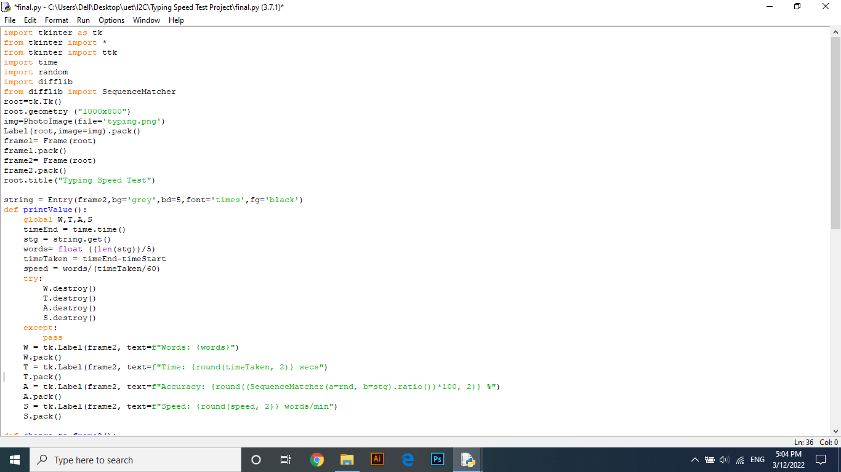

1. The main function is defined. The geometry of the screen is also defined. We have set 2 frames for this project which are also defined here.



1. A function PrintValue has been defined which will display the time, speed, words and accuracy when called after taking input from the user.



1. A function Change_to_Frame is defined which will change frame 1 to frame 2. Frame 1 has the title and the check boxes for Letters and Sentences. Frame 2 displays the random letter/sentence will displays output.

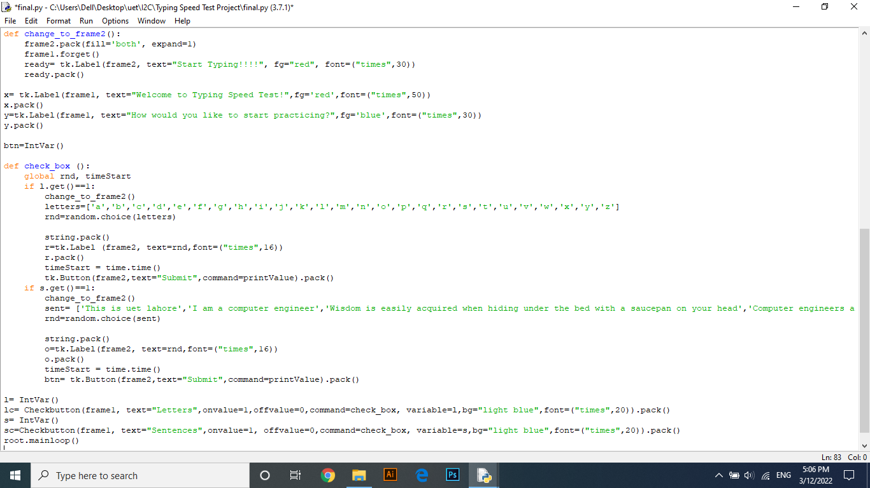

1. A function Check_box has been defined which displays the check boxes for letters and sentences. Then applies a condition that if the Letter check box is ticked then display random letters and if Sentences check box is ticked then random sentence is displayed. It also packs the Submit entry. When submit is clicked, the function PrintValue is called. Then the mainloop is closed. The code ends here.



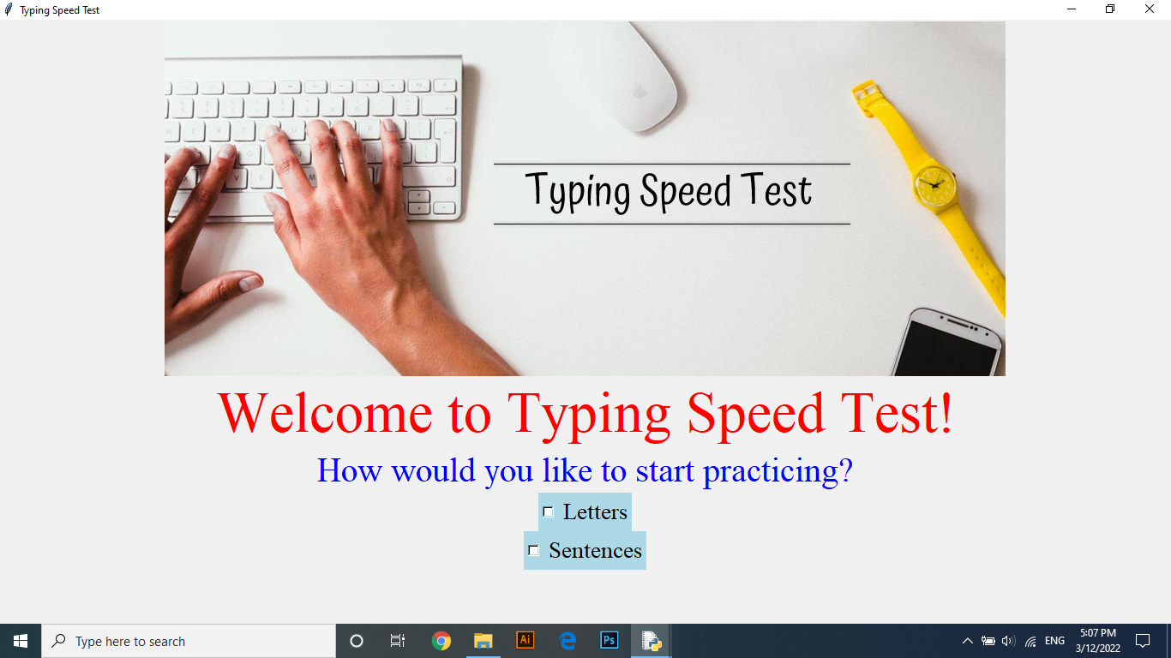**Output:**

